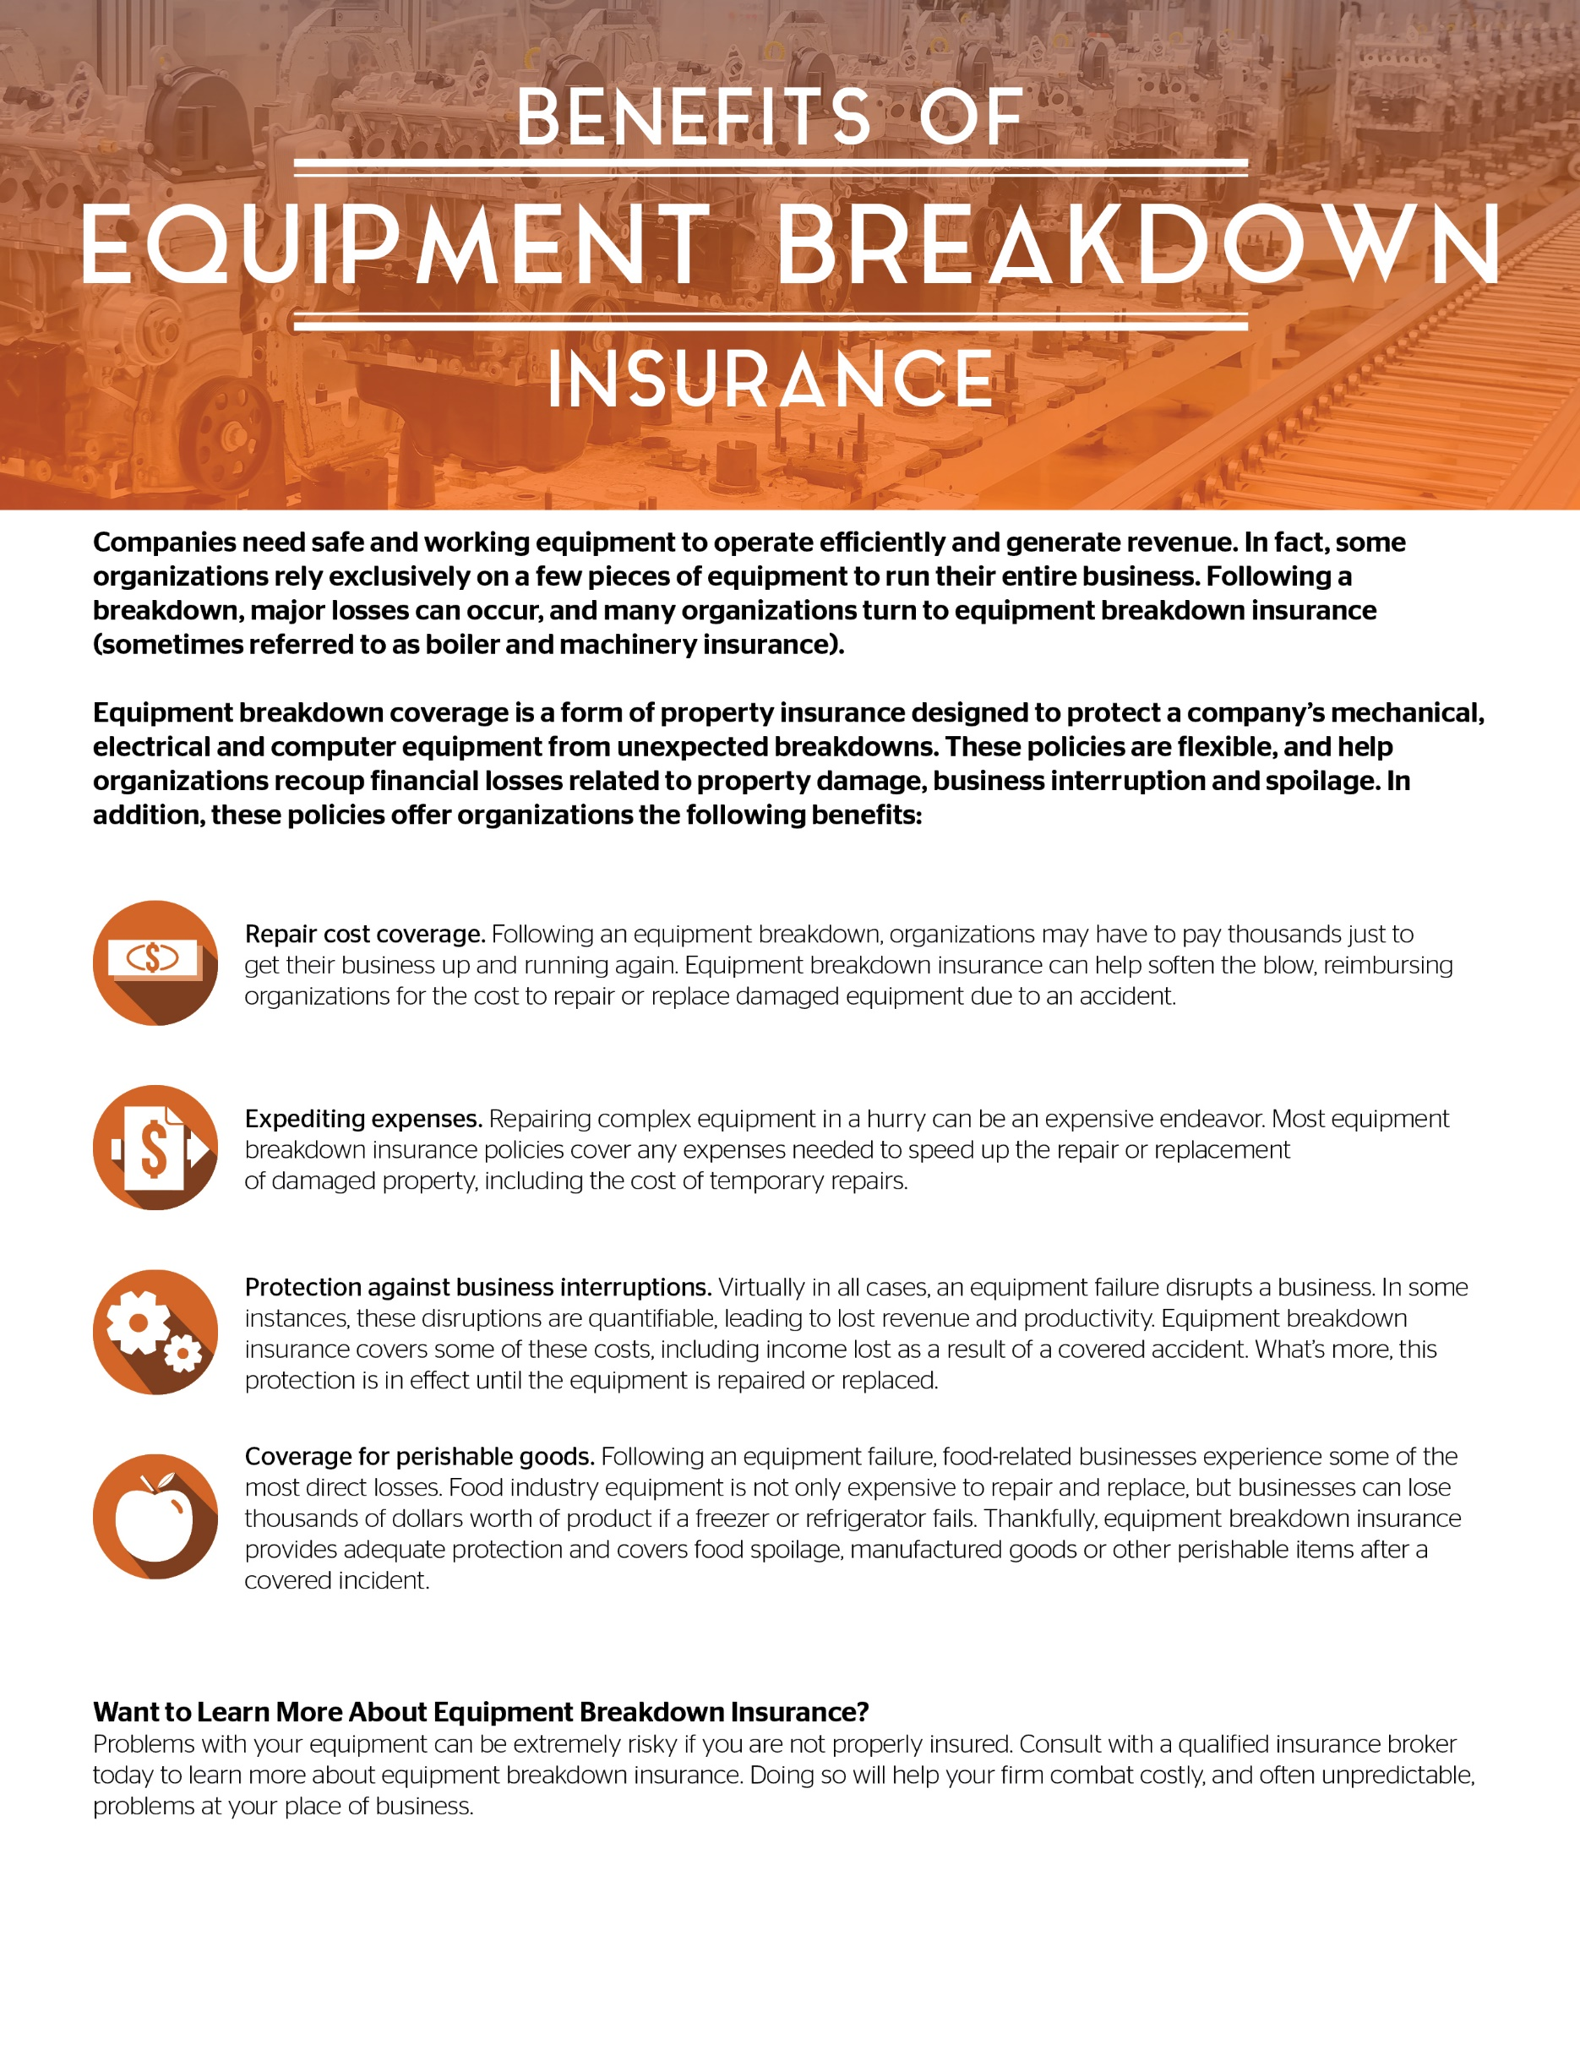s

© 2018-2019 Zywave, Inc. All rights reserved

Presented by: TIG Advisors