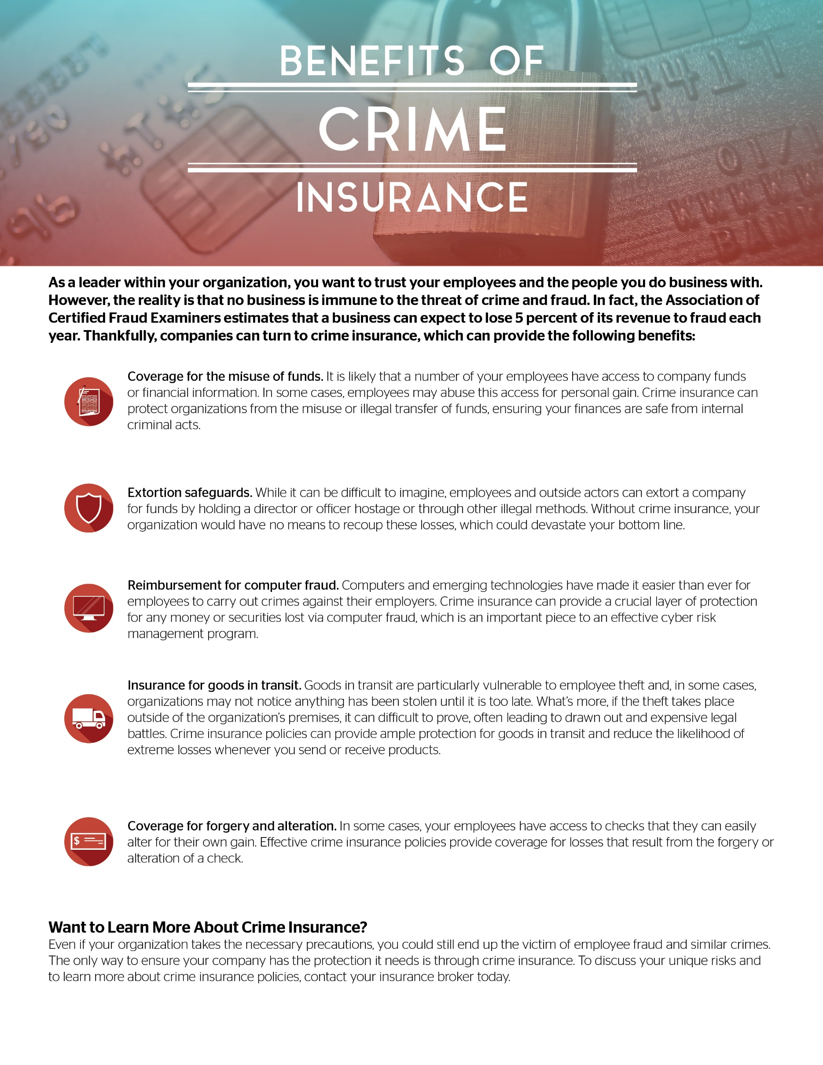

© 2017 Zywave, Inc. All rights reserved.

Presented by: TIG Advisors